Reasoning System (for Medication of heart diseases)

END TERM REPORT

by

|  |  |  |  |
| --- | --- | --- | --- |
| Registration No | Name of Student | Roll No | Section |
| 11805900 | Konakalla Syam Sundar | **36** | K18VQ(GROUP-2) |
| 11805852 | Abhishekh Kumar Thakur | **34** | K18VQ(GROUP-2) |
| 11805672 | Khandekar Gaurav Madhukar | **33** | K18VQ(GROUP-2) |



Department of Intelligent Systems

School of Computer Science Engineering

Lovely Professional University, Jalandhar

04-2020

Student Declaration

This is to declare that this report has been written by me/us. No part of the report is copied from other sources. All information included from other sources have been duly acknowledged. I/We aver that if any part of the report is found to be copied, I/we are shall take full responsibility for it.

Signature: Gaurav

Khandekar Gaurav Madhukar

Roll no:33

Signature: Abhishekh

Abhishekh Kumar Thakur

Roll no:34

Signature: syam sundar

Konakalla Syam Sundar

Roll no:3

Place: Lovely Professional University

Date: 02-04-2020

TABLE OF CONTENTS

TITLE PAGE NO.

1. Background and objectives of project assigned .......................... 1

2. Description of Project……………………………………..……. 2

3. Description of Work Division in terms of Roles among Students. 3

4. Implementation of scheduled work of Project…………………… 4

5. Technologies and Framework to be used………………………... 5

6. SWOT Analysis achieved in project…………………………….. 6

BONAFIDE CERTIFICATE

Certified that this project report “ Reasoning System (for Medication of heart diseases) ” is the bonafide work of “ Khandekar Gaurav Madhukar, Abhishekh Kumar Thakur, Konakalla Syam Sundar ” who carried out the project work under my supervision.

<< …..………………….>>

<<………………………>>

<<……………………….>>

<<…...…………………..>>

<<…….…………………>>

Background and objectives of the project assigned

This is project overview of for Medication of heart diseases

by applying system Reasoning. Diagnosis of disease is a vital and intricate job in medicine. There are a lot of Artificial Intelligence (AI) techniques to determine. After comparisons were made between those techniques, system Reasoning is chosen to medication of heart disease. System presented in Java to make it accessible for users like health professionals and doctors. The result of this designed system to diagnose the heart disease effectively. python language as the programming language.

This chapter briefly describes the Case-Based Reasoning System for Support Diagnosis of Heart Disease. In this chapter, there are five sections which include the introduction of the project and problem statement related to this project. Third section is the objectives to be achieved and fourth section is the scopes. Last section is the thesis organization.

Introduction The term ‘Heart Disease’ encompasses the diverse diseases that affect heart. The number of people suffering from heart disease is on the rise. The report from World Health Organization shows us a large number of people that die every year due to the heart disease all over the world. Heart disease is also stated as one of the greatest in Africa, America and also Asia. Correct diagnosis of heart disease at an early stage is a demanding task due to the complex interdependence on various factors. Another major challenge faced by hospital is the provision of quality services at affordable cost. These are the motivations to develop medical diagnosis prediction system which can predict heart disease by processing the previous known cases. 2 Working on heart disease patient databases is one kind of a real-life application. The databases include several factors and attributes. Therefore, was proposed for supporting diagnosis of heart disease in this study. this method in Artificial Intelligent is applied in this system by a real medical data set taken from machine learning. the data set donor has mentioned that there were some papers that focused on the data by different techniques. There are some papers using different technique to predict or deduce heart disease been used in various problem-solving areas such as financial forecasting, credit analysis and medical diagnosis. In addition, CBR is chosen because CBR is appropriate in medicine for some important reasons: cognitive adequateness, explicit experience, duality of objective and subjective knowledge, and system integration. CBR is unlike the traditional rule-based approach in which expert knowledge must be represented in “if-then” rules, CBR manages attributes to be grouped and stored.

Generally, doctors and health professionals use their knowledge and experience to make decision for the diagnosis of heart disease for patients. Usually, most of the medical data collected from patients are just saved in files or kept in folders. Generally, those huge amounts of messy medical records have not meaning for users. Using CBR, a technique which solves a new problem by remembering a previous case and by reusing information and knowledge of that case, CBR turn those data into useful information that can help to make decision support system for the diagnosis of heart disease. This system can be used to assist doctor and support education for the undergraduate and postgraduate young physicians as a tool to improve the quality of care for the patients. This system can be used as a reference for those student and new doctor. Presently, doctors have difficulties in determining heart disease in a new patient who does not have existing medical record. Therefore, those data can be used to diagnose heart disease for new patients who do not have existing medical records. This system is designed to assist doctor and health professionals in determining the diagnosis of patient data. Therefore, this system could help doctors and health professionals to determine the diagnosis and analysis of the patient health status.

Objectives of this study are: 1 To develop an intelligent clinical decision support system for the diagnosis of heart disease.

2. To use CBR algorithm to predict heart disease in patient.

Scope The way of doctors and health professionals diagnose heart disease depends on their experience and knowledge. That way is similar to decision support system using CBR approach. CBR algorithm has 4 phases which are retrieve, reuse, revise and retain. But this system only uses retrieve and reuse technique in whole cycle of CBR algorithm. In addition, this project retrieves the dataset from, and reuses its database to support the system. Secondly, this system only can support prediction for diagnosis of heart disease using same attributes in the system database. Limiting the amount and areas of attributes can help this system in more constant way. To help more users’ access to the system, accessibility is needed and applied in this project.

Description of Project

Heart disease is a class of diseases that involves the heart or blood vessels. Heart disease is the second leading cause of death in Malaysia for men and women. There are many different forms of heart disease. The most common cause of heart disease is narrowing or blockage of the coronary arteries which are the blood vessels that supply blood to the heart itself. This is called coronary artery disease and it happens slowly over time. It is the major reason people have heart attack. Other types of heart problems may happen to the valves in the heart, or the heart may not pump well and causes heart failure. There are some people who are born with heart disease. Many things increase the risk for heart disease, and mostly people want to reduce those risk factors. In this case, the factors are:

* Having diabetes which is a strong risk for heart disease.
* Substance abuse such as cocaine
* Being overweight
* Not getting enough exercise and feel depressed or having excess stress
* Smoking
* High blood pressure increases the risks of heart disease and heart failure
* Excess cholesterol in blood build up inside the walls of heart’s arteries

People can help to reduce the risk of heart disease by taking steps to control factors mentioned, for example by controlling the blood pressure, lowering the cholesterol level, refraining from smoking and having enough exercise.

**METHODOLOGY SELECTED:** FUZZY LOGIC

**CODE FOR THE PROJECT:**

from tkinter import * #Importing modules

from PIL import ImageTk,Image

from tkinter import messagebox

#==================================================First Page================================================================

def landing_page():

global Landingpage

Landingpage = Tk()#Creating a window

Landingpage.configure(bg = "#D79922")#45A29E

Landingpage.title("Medication Of Heart Disease.") #Window Title

#Landingpage.iconbitmap("ap.ico")

width = Landingpage.winfo_screenwidth()#Geometry Of Window(Width and Height)

height = Landingpage.winfo_screenheight()

Landingpage.geometry(f'{width}x{height}')

#==============================================Canvas for Image==================================================================

canvas = Canvas(Landingpage,width = 900,height = 380)

image = ImageTk.PhotoImage(Image.open("healthy-life-banner.jpg"))

canvas.create_image(448,190,image = image)

canvas.place(relx = 0.20,rely = 0.2)

#===============================================Upper Frame========================================================================

frame = Frame(Landingpage,bg = "#45A29E",height = 150,width = 1500,padx = 0)

frame.place(relx = 0.01,rely = 0.01)

txt = """ "The most chronic heart disease is caused by having greediness in your heart.

Go for check ups regularly and learn how to swallow those lumpy pills of generousity.

Be kind and be healthy." """

Label(frame,bg = "purple",fg = "white",text = txt,height = 3,width = 81,font =('comic sans ms','22')).place(relx = 0.01,rely = 0.1)

#===============================================Lower Frame=====================================================================

lframe = Frame(Landingpage,bg = "#45A29E",height = 180,width = 1500,padx = 0)

lframe.place(relx = 0.01,rely = 0.71)

txt1 = "Welcome to the world of Medication Of Heart Disease. Click 'Start' and select your Symptoms to know your Disease."

Label(lframe,bg = "purple",fg = "white",text = txt1,height = 3,width = 98,font =('comic sans ms','18')).place(relx = 0.007,rely = 0.05)

Button(lframe,text = "Start",font =('comic sans ms','18'),cursor = "hand2",bg = 'green',fg = 'white',activebackground = 'green',command = lambda:Medication()).place(relx = 0.45,rely = 0.64)

Landingpage.mainloop()

#===================================================Symptoms Page==============================================================

def Medication():

global win

win = Toplevel(Landingpage)

win.title("Medication Of Heart Disease")

#win.iconbitmap("ap.ico")

global width

global height

width = win.winfo_screenwidth()

height = win.winfo_screenheight()

win.geometry(f'{width}x{height}')

canvas = Canvas(win,width = width,height = height)

image = ImageTk.PhotoImage(Image.open("Background_image.jpg"))

canvas.create_image(0,0,anchor = "nw",image = image)

canvas.place(relx = 0,rely = 0)

#===============================================Labels=====================================================================

for i in range(0,len(Symptoms)):

if(i>19):

i = i-20

Label(win,text =Symptoms[i+20],font =('comic sans ms','20'),bg = "green",fg = "white",anchor = "w",width = 20).place(relx = 0.69,rely = i*0.1)

elif(i>9):

i = i-10

Label(win,text =Symptoms[i+10],font =('comic sans ms','20'),bg = "green",fg = "white",anchor = "w",width = 20).place(relx = 0.34,rely = i*0.1)

else:

Label(win,text =Symptoms[i],bg = 'green',fg = 'white',font =('comic sans ms','20'),anchor = "w",width = 20).place(relx = 0,rely = i*0.1)

#=============================================DropDown Box==================================================================

sev = [0,1,2,3,4,5]

variable = [0 for i in range(0,len(Symptoms))]

for i in range(0,len(Symptoms)):

variable[i] = IntVar()

variable[i].set(0)

d = OptionMenu(win,variable[i],*sev)

d.config(bg = "lightsalmon",activebackground = "pink",anchor = "w",relief = "flat",font =('comic sans ms','12'),width = 10,height = 2,cursor = "hand2")

if(i>19):

i = i-20

d.place(relx = '0.905',rely = i*0.1)

elif(i>9):

i = i-10

d.place(relx = '0.555',rely = i*0.1)

else:

d.place(relx = '0.215',rely = i*0.1)

#===================================================Logic===================================================================

global getlist

getlist = []

def get():

for i in range(0,len(variable)):

if variable[i].get()>0 and Symptoms[i] not in getlist:

#print(Symptoms[i],"is:",variable[i].get())

getlist.append(Symptoms[i])

#print(getlist)

if len(getlist)>0:

result_page()

else:

messagebox.showinfo("Warning","Please Select your Symptoms...!")

Button(win,text ="SUBMIT",bg = 'saddlebrown',fg = 'black',activebackground = "saddlebrown",cursor = "hand2",font =('comic sans ms','20'),anchor = "center",width = 20,command = lambda:get()).place(relx = 0.72,rely = 0.88)

win.mainloop()

#==================================================Result Page===================================================================

def result_page():

global result

result = Toplevel(win)

result.title("Result Page")

#result.iconbitmap("ap.ico")

result.geometry(f'{width}x{height}')

canvas = Canvas(result,width = width,height = height)

image = ImageTk.PhotoImage(Image.open("Background_image.jpg"))

canvas.create_image(0,0,anchor = "nw",image = image)

canvas.pack()

#===================================================Logic=======================================================================

Label(result,text = "You Selected Below Symptoms:",bg = 'chocolate1',fg = 'white',font =('comic sans ms','20'),anchor = "w").place(relx = 0.05,rely = 0.04)

for i in range(0,len(getlist)):

if(i>9):

i = i-9

Label(result,text = str(i+9)+")"+getlist[i],bg = 'green',fg = 'white',font =('comic sans ms','20'),anchor = "w",width = 25).place(relx = 0.4,rely = i*0.1)

i = i + 1

Label(result,text = str(i)+")"+getlist[i-1],bg = 'green',fg = 'white',font =('comic sans ms','20'),anchor = "w",width = 25).place(relx = 0.1,rely = i*0.1)

global count1,count2,count3,count4,count5,count6

count1 = count2 = count3 = count4 = count5 = count6 = 0

for i in getlist:

if i in Coronary_Artery_Diseases:

count1 += 1

elif i in Myocardial_Infarction:

count2 += 1

elif i in Heart_Defects:

count3 += 1

elif i in Arythmia:

count4 += 1

elif i in Hypotension:

count5 += 1

elif i in Peripheral_Arterial_Disease:

count6 += 1

if count1<=3 and count2<= 3 and count3<= 3 and count4<= 3 and count5<= 3 and count6 <= 3:

messagebox.showwarning("Warning","InSufficient Data,Please Select Correct Symptoms...!")

getlist.clear()

if (count1 + count2 + count3 + count4 + count5 + count6) >10 :

messagebox.showwarning("Warning","Please Select Correct Symptoms...!")

getlist.clear()

lb1 = Label(result,bg = 'chocolate1',width = 22,height = 10,fg = 'white',font =('comic sans ms','20'),anchor = "w")

lb1.place(relx = 0.65,rely = 0.14)

if count1 > 3:

Label(lb1,bg = 'pink',text = "You are suffering from ",fg = 'black',width = 22,font =('comic sans ms','15')).place(relx = 0.1,rely = 0.2)

Label(lb1,bg = 'pink',text = "Coronary Artery Disease.",fg = 'black',font =('comic sans ms','20','bold')).place(relx = 0.01,rely = 0.3)

elif count2 > 3:

Label(lb1,bg = 'pink',text = "You are suffering from ",fg = 'black',width = 22,font =('comic sans ms','15')).place(relx = 0.1,rely = 0.2)

Label(lb1,bg = 'pink',text = "Myocardial Infarction",fg = 'black',font =('comic sans ms','20','bold')).place(relx = 0.08,rely = 0.3)

elif count3 > 3:

Label(lb1,bg = 'pink',text = "You are suffering from ",fg = 'black',width = 22,font =('comic sans ms','15')).place(relx = 0.1,rely = 0.2)

Label(lb1,bg = 'pink',text = "Heart Defects",fg = 'black',font =('comic sans ms','20','bold')).place(relx = 0.25,rely = 0.3)

elif count4 > 3:

Label(lb1,bg = 'pink',text = "You are suffering from ",fg = 'black',width = 22,font =('comic sans ms','15')).place(relx = 0.1,rely = 0.2)

Label(lb1,bg = 'pink',text = "Arythmia",fg = 'black',font =('comic sans ms','20','bold')).place(relx = 0.26,rely = 0.3)

elif count5 > 3:

Label(lb1,bg = 'pink',text = "You are suffering from ",fg = 'black',width = 22,font =('comic sans ms','15')).place(relx = 0.1,rely = 0.2)

Label(lb1,bg = 'pink',text = "Hypotension",fg = 'black',font =('comic sans ms','20','bold')).place(relx = 0.25,rely = 0.3)

elif count6 > 3:

Label(lb1,bg = 'pink',text = "You are suffering from ",fg = 'black',width = 22,font =('comic sans ms','15')).place(relx = 0.1,rely = 0.2)

Label(lb1,bg = 'pink',text = "Peripheral Arterial Disease",fg = 'black',font =('comic sans ms','19','bold')).place(relx = 0.02,rely = 0.3)

def destroy():

result.destroy()

win.destroy()

Landingpage.destroy()

Button(lb1,text = "OK",fg = "white",bg = "red",activebackground = "red",font =('comic sans ms','20'),command = lambda:destroy()).place(relx = 0.4,rely = 0.6)

Label(lb1,bg = 'Black',text = "(Click OK to exit)",fg = 'white',font =('comic sans ms','15')).place(relx = 0.27,rely = 0.8)

result.mainloop()

#======================================================Main=====================================================================

Heart_Diseases = ['Coronary Artery Diseases','Myocardial Infarction','Arythmia',

' Heart Defects' ,' Peipheral Heart Disease', 'Hypotension']

Symptoms = ['Shortness Of Breathing','Sweating','Weakness','Nausea','Dizziness','Palpitations',

'Rapid Heartbeat','Tightness in the Chest','Couch','Anxiety','Fast Heart Rate','Swelling Of Body Tissues',

'Abnormal Heart Rhythms','A Bluish Tint On Skin','Tiring Quickly upon Exertion','Fluttering in Chest',

'Racing HeartBeat','Chestpain','Fainting','Lightheadedness','Fatigue','Paleskin','Weak and Rapid Pulse'

,'Lack Of Concentration','Hairloss on feet and legs','Leg Weakness','Lowerleg feelscold','Numbness in Legs',

'Brittle toe Nails']

Coronary_Artery_Diseases = ['Shortness Of Breathing','Sweating','Weakness','Nausea','Dizziness','Palpitations','Rapid Heartbeat']

Myocardial_Infarction = ['Tightness in the Chest','Sweating','Couch','Nausea','Anxiety','Fast Heart Rate']

Heart_Defects = ['Swelling Of Body Tissues','Abnormal Heart Rhythms','A Bluish Tint On Skin','Tiring Quickly upon Exertion']

Arythmia = ['Fluttering in Chest','Racing HeartBeat','Chestpain','Sweating','Fainting','Anxiety']

Hypotension = ['Lightheadedness','Fainting','Nausea','Fatigue','Paleskin','Weak and Rapid Pulse','Lack Of Concentration']

Peripheral_Arterial_Disease = ['Hairloss on feet and legs','Leg Weakness','Lowerleg feelscold','Numbness in Legs','Brittle toe Nails']

landing_page()

**OUTPUT:**

FIRSTPAGE

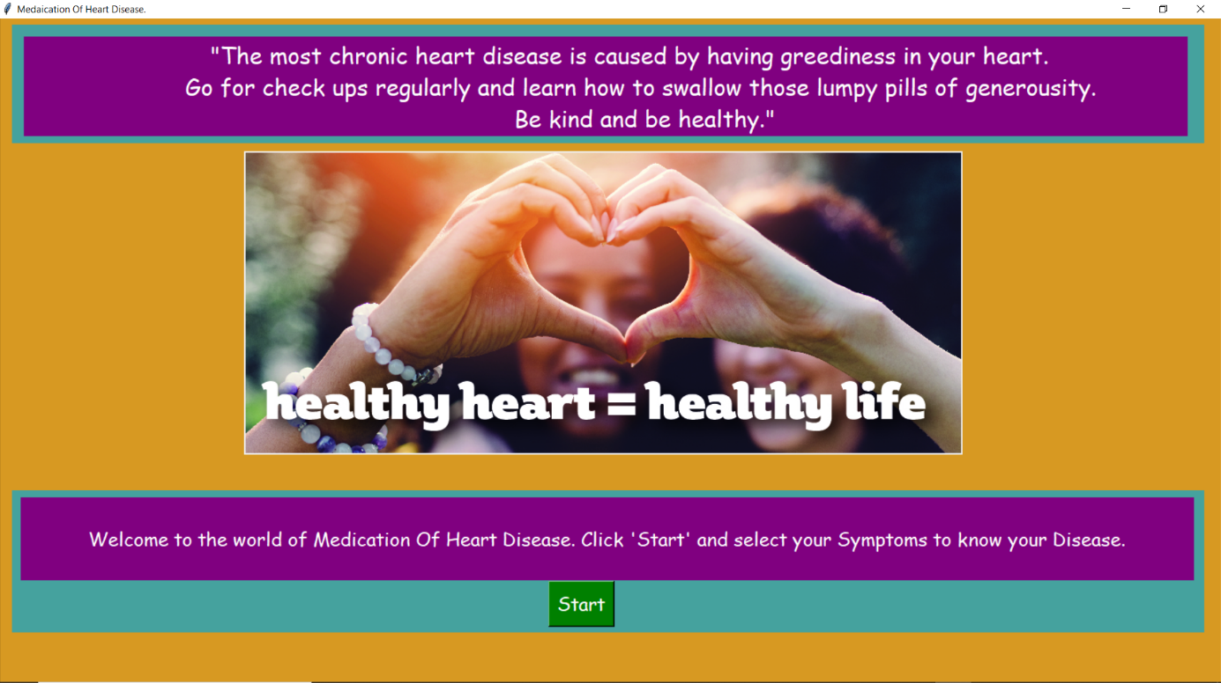

SECONDPAGE:

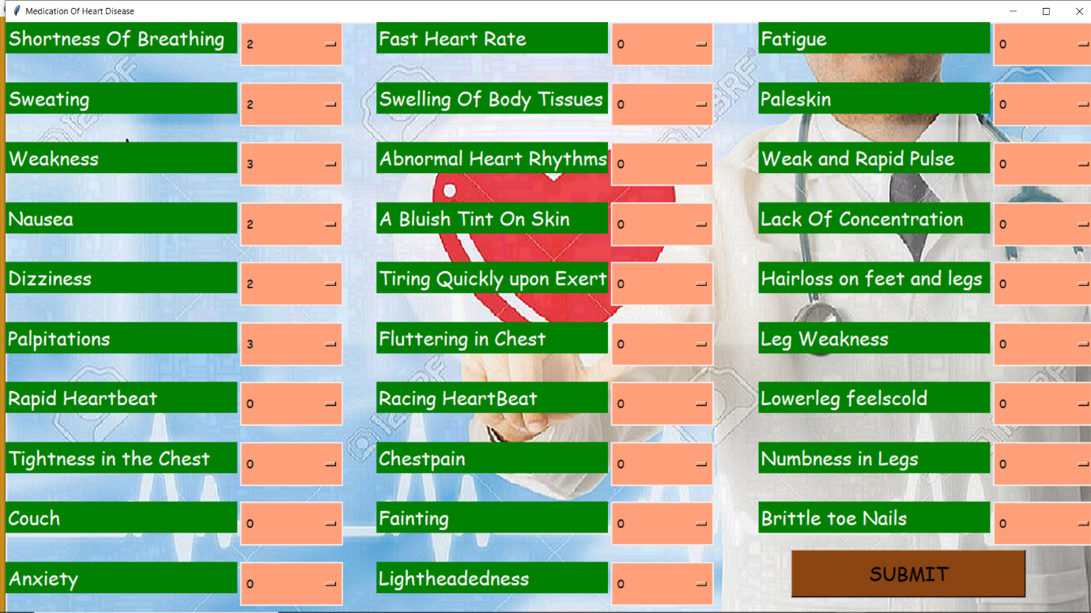

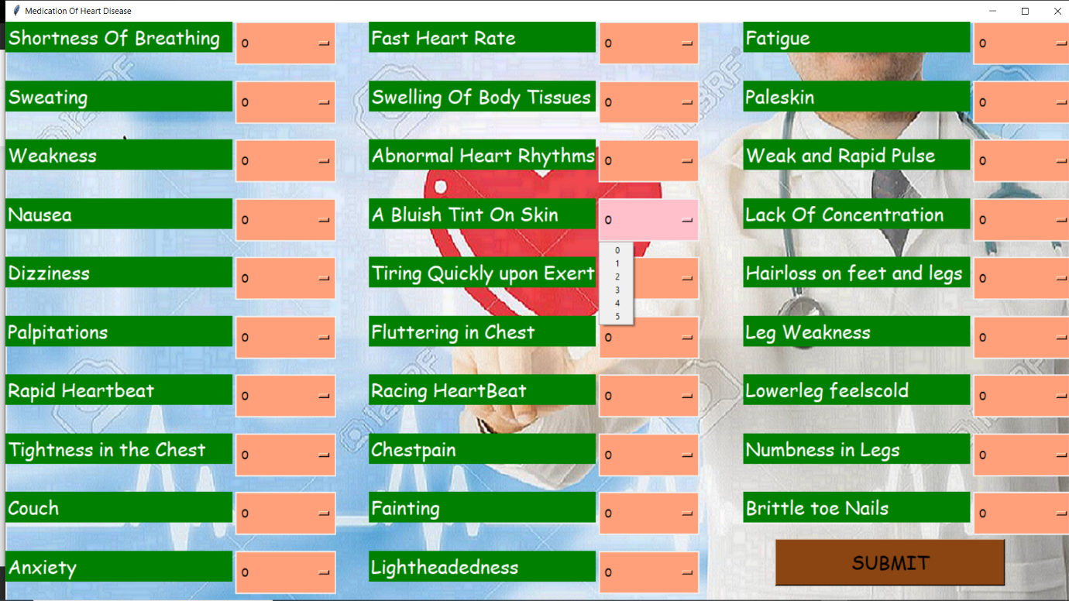

THIRDPAGE:

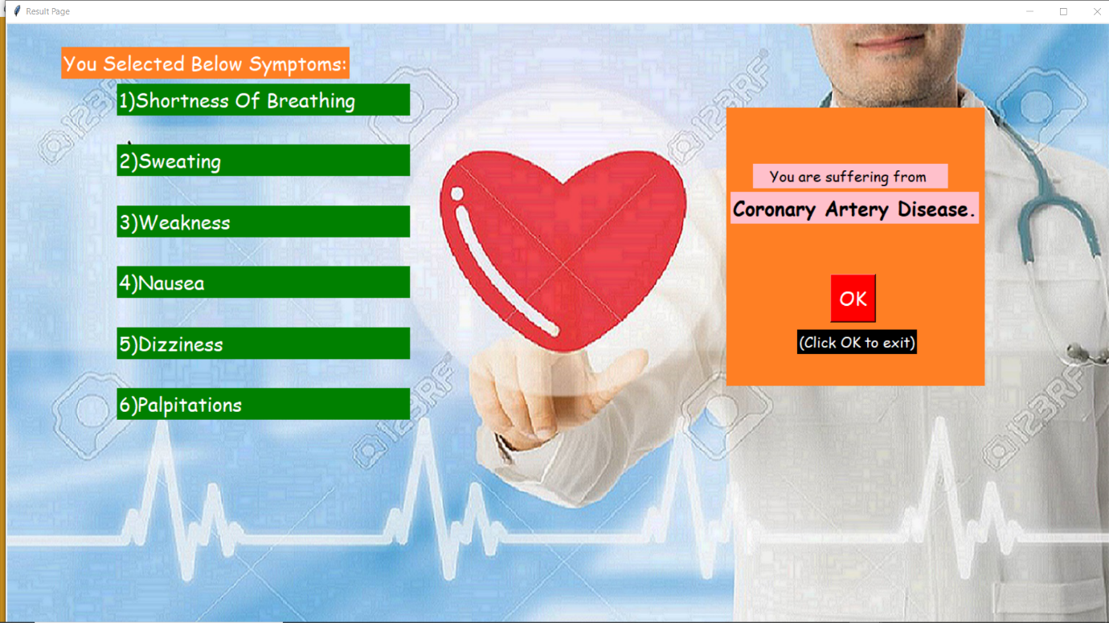

**TESTCASES:**

TESTCASE1:

If user selects NONE of the symptoms:

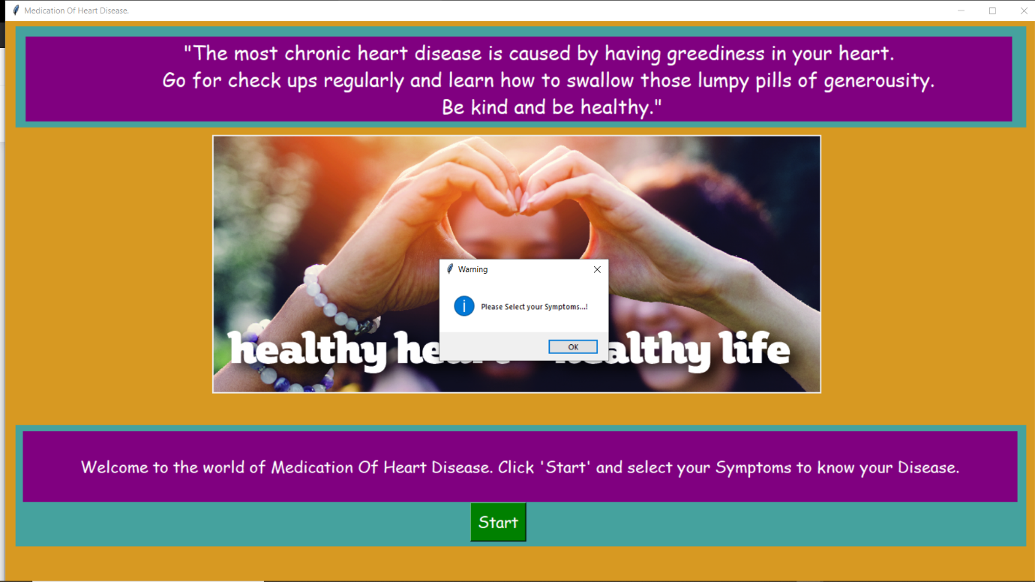

TESTCASE2:

If User Selects ALL of the Symptoms:

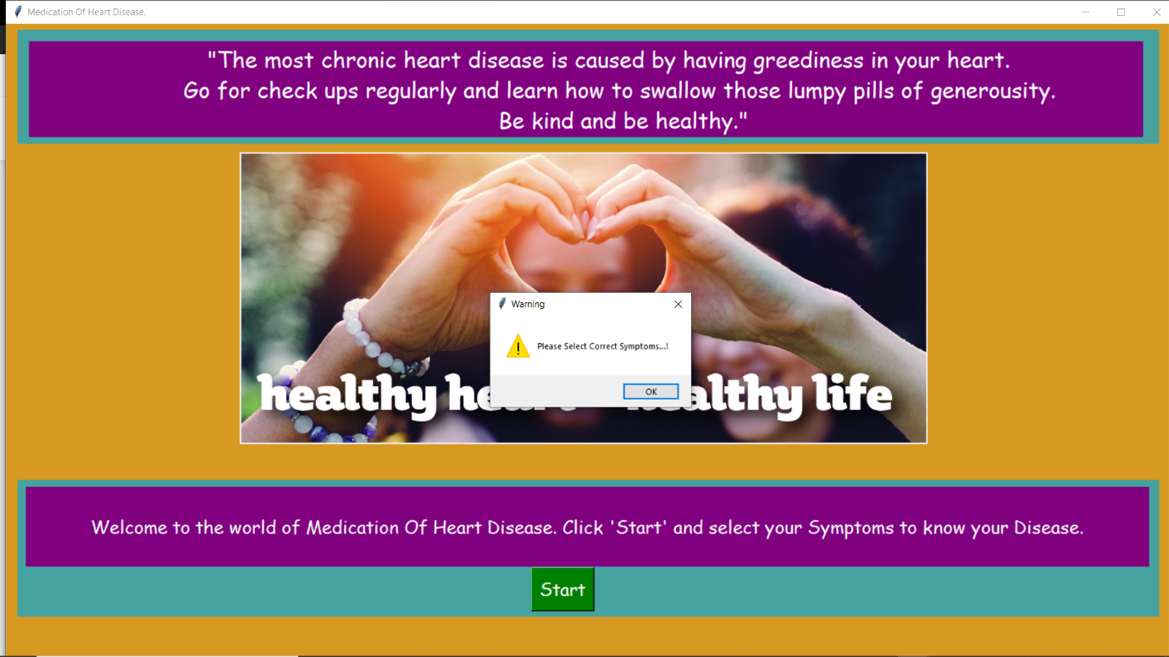

TESTCASE3:

If user selects INCORRECT Symptoms:



TESTCASE4:

If user selects CORRECT Symptoms:

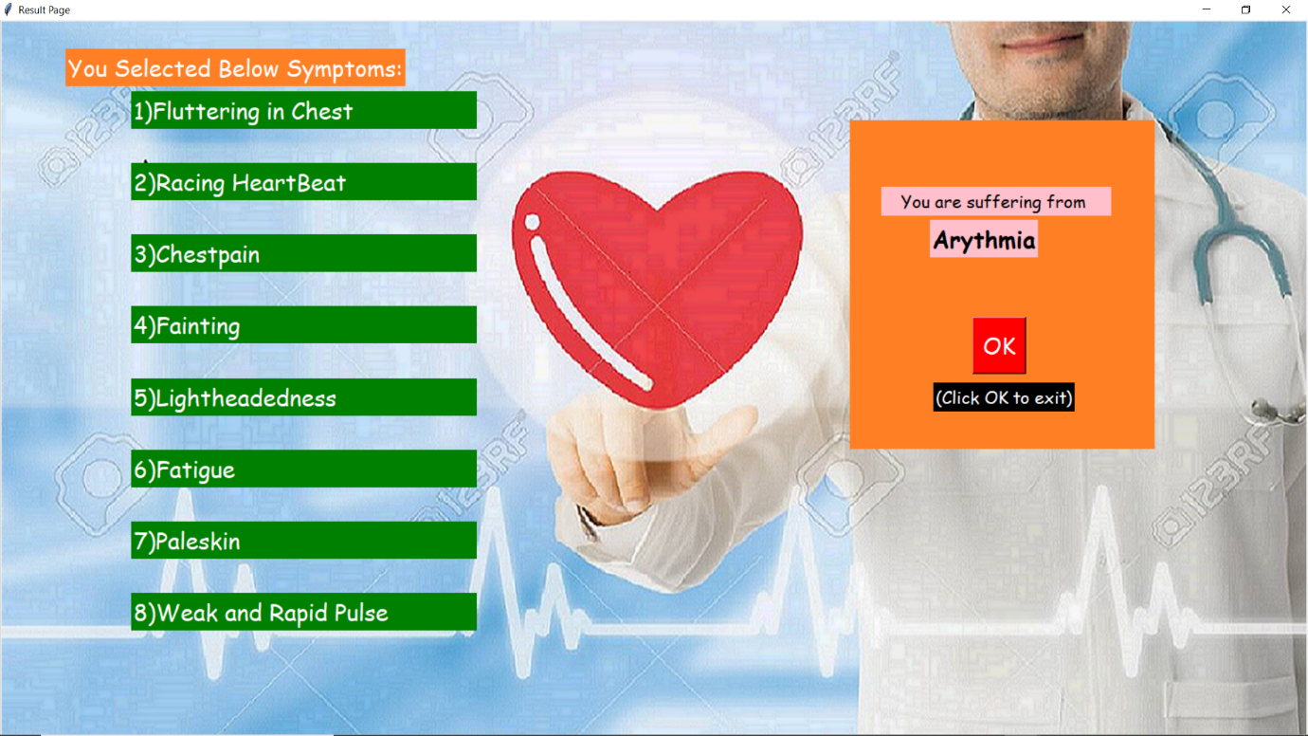



**VIDEO OF WORKING PROJECT**

**MODULES DONE BY:**

FIRST PAGE : Syam Sundar,Gourav.

SECOND PAGE :Syam Sundar,Abhishek

THIRD PAGE : Abhishek,Gourav And Syam Sundar.

**FRAMEWORKS USED:**

Python – Tkinter Frame work.